TREASURED KIDS NEST NURSERY AND PRIMARY SCHOOL
BABY CLASS NUMERACY
Name: ________________________________________
- Read the following numbers I - I0.
I 2 3 4 5 6 7 8 I0
o
- Copy number I
I I I
I

I I I

- Trace the following numbers.

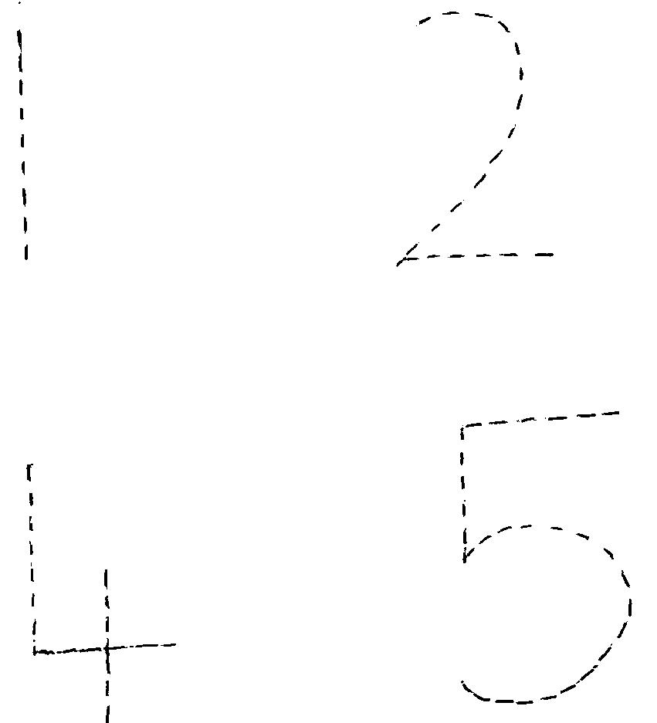

- Match the same number.
I 5
2 4
3 2
4 3
5 I
- Colour and complete these shapes.



- Count and match numbers to pictures.

I | 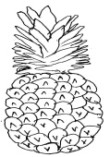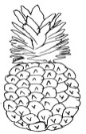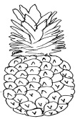
2 | 
3 | 

- Match the same shapes.

- Match the same numbers and shade the objects.

2 | 5
4 | 2
5 | 4

- Shade numbers 4 and 5.


5

success

